Identifying Student Typical Goals
- Find “Mekia Johnson.”
- Circle her current RIT score.
- Circle the number of RIT score points a student in her grade level with the same RIT score would typically grow by next spring.
- Circle her projected RIT score for spring 2017 if she makes “Typical Growth.”
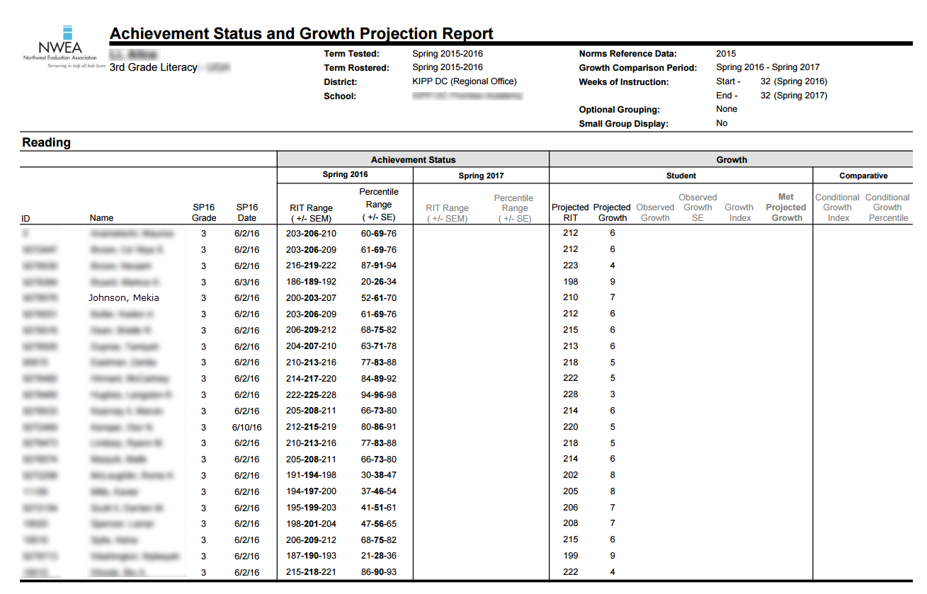

Calculating Student Tiered Goals
Using Mekia’s typical goal, her percentile, and her grade level, what tiered goal would you set for her?

Again, how many RIT score points does NWEA project her to grow by the spring? _________
What grade is she in? __________
What percentile did she score in? __________
What is the appropriate “tiered target” multiplier? ___________

Mekia’s typical growth points x multiplier = Tiered growth points

How many RIT score points does Mekia need to gain to make tiered growth? ___________

If Mekia meets her tiered goal, what will her spring 2017 RIT score be? ___________

Grades: K-3rd | Multiplier
Bottom (1-24th percentile): | 1.5x typical growth
2^{nd:} (25-49th percentile): | 1.5x typical growth
3^{rd:} (50-74th percentile): | 1.25x typical growth
Top (75-99th percentile): | 1.25x typical growth
Grades: 4-9th: | Multiplier
Bottom (1-24th percentile): | 2x typical growth
2nd (25-49th percentile): | 1.75x typical growth
3rd (50-74th percentile): | 1.5x typical growth
Top (75-99th percentile): | 1.25x typical growth

