General Data Viz/Qlik Sense Creation Best Practices
- Identify possible use-case scenarios from all possible stakeholders using report
- Create application and load data
  - Consider upload method based on whether data will need to be updated in the app
  - Qlik will automatically associate tables based on field names/column headers
  - Double-check your data model and connections between tables
- Determine metrics
  - Use quick calculations for fields requiring simple aggregation (sum, avg, etc.)
  - Create new master measures using set analysis for more complex calculations (median, ttest, etc.) or for when you would have used SUMIF/AVERAGEIF types of functions in Excel
  - Changes to mast measures proliferate throughout the app when you make them once
- Choose visualizations
  - Visualizations can be flat and feature one field or dynamic with drill-down dimensions created by you in the master items
  - Minimize the number of visualizations to 4-6 per sheet
  - Vary the visualization type and orientation to keep it interesting, but remember that to many people color matters so carefully choose your colors and conditionally formatting
- Roll it all out!
  - If you have admin access you can post your application to folks in your LEA by going to: analysis.osse.dc.gov/qmc
  - Or you can share the QVF file with another person who has Qlik Desktop
  - Or you can import the app to QlikCloud.com and share it from Qlik’s share site

Step 1: Create New Qlik Sense App and Load Data
Login to the OSSE Analysis Tool: http://analysis.osse.dc.gov/hub/my/work
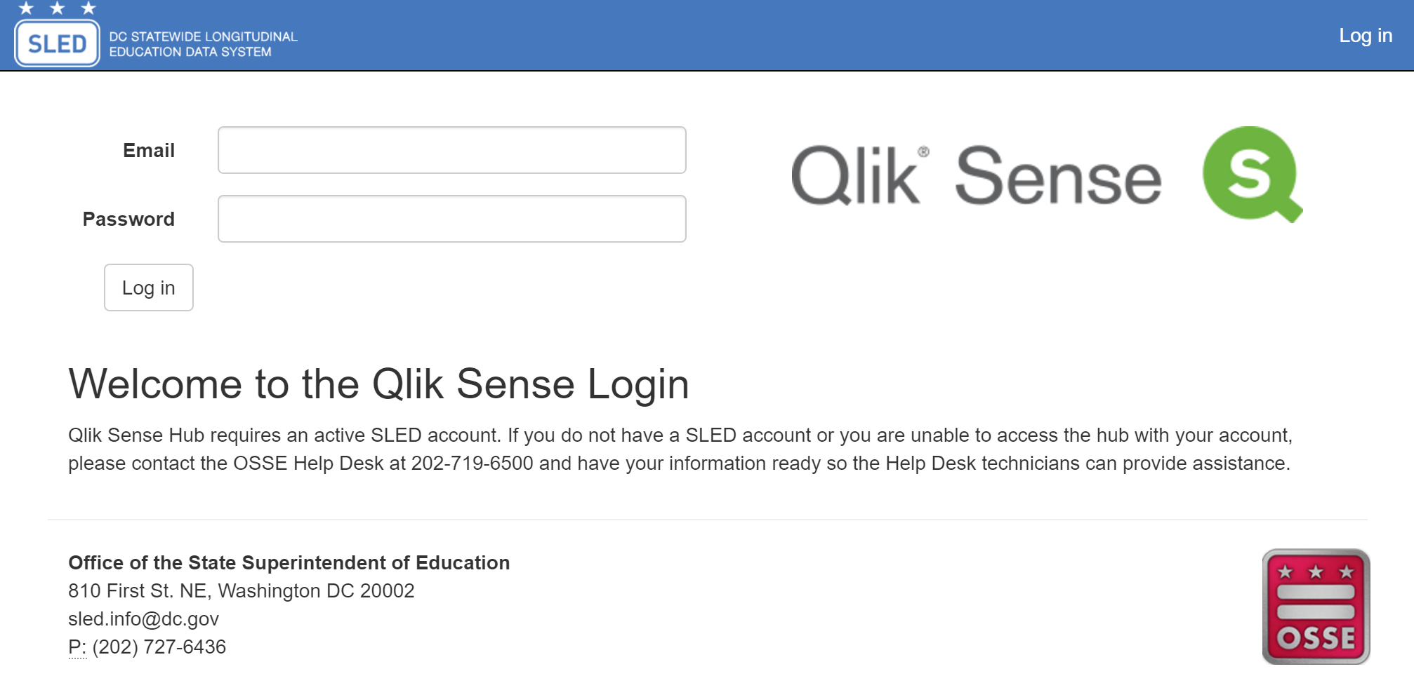
After successful login, click the “Create New App” button from the Qlik Sense Hub screen
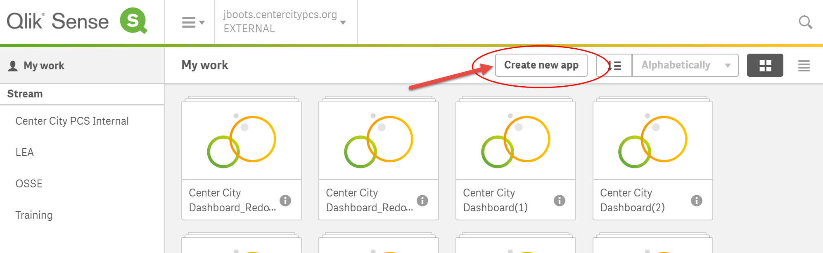
…and give it a fun name, like “EOY Dashboard Trial”
Click “Add Data”
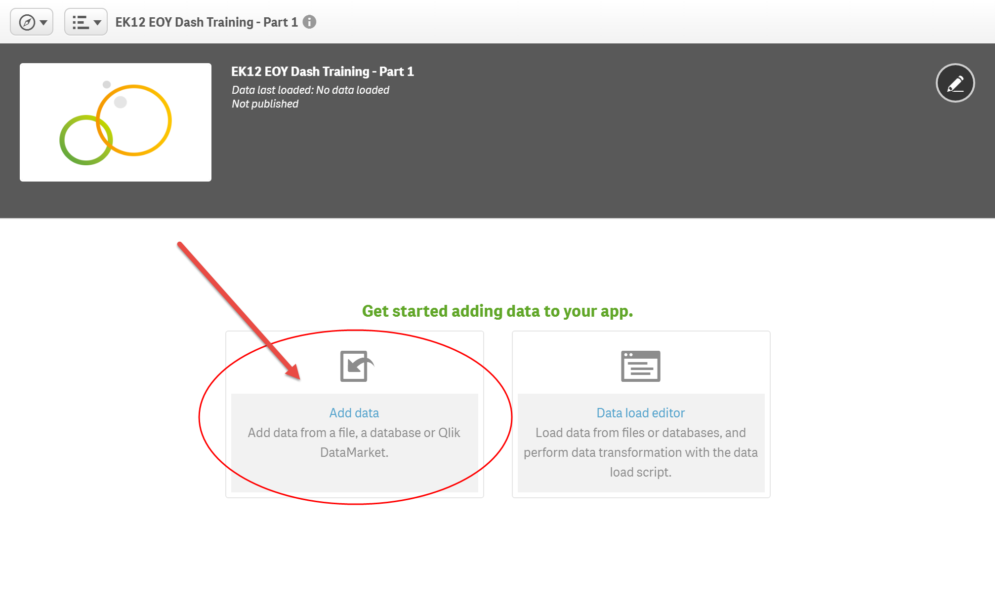
For this training, we are using three sample student data files we made available online. Please ensure you have downloaded the files and saved them somewhere on your computer. First, add the “TrainingStudents” file to Qlik:
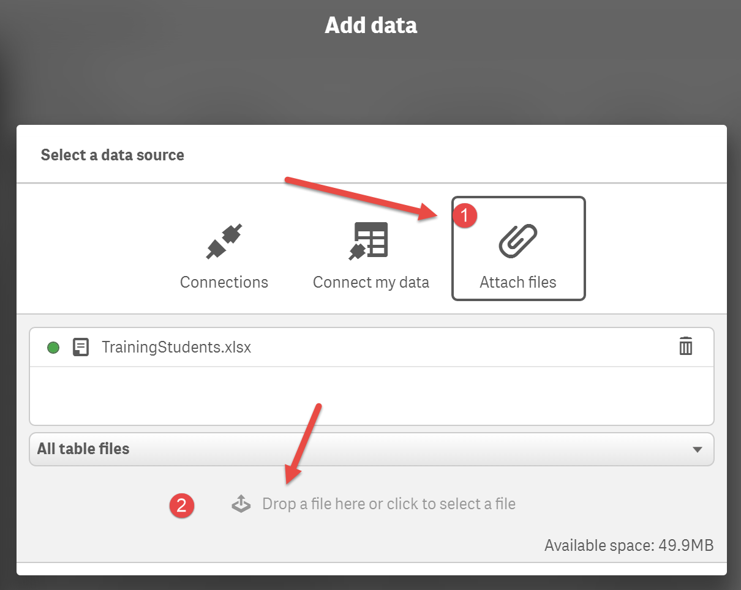
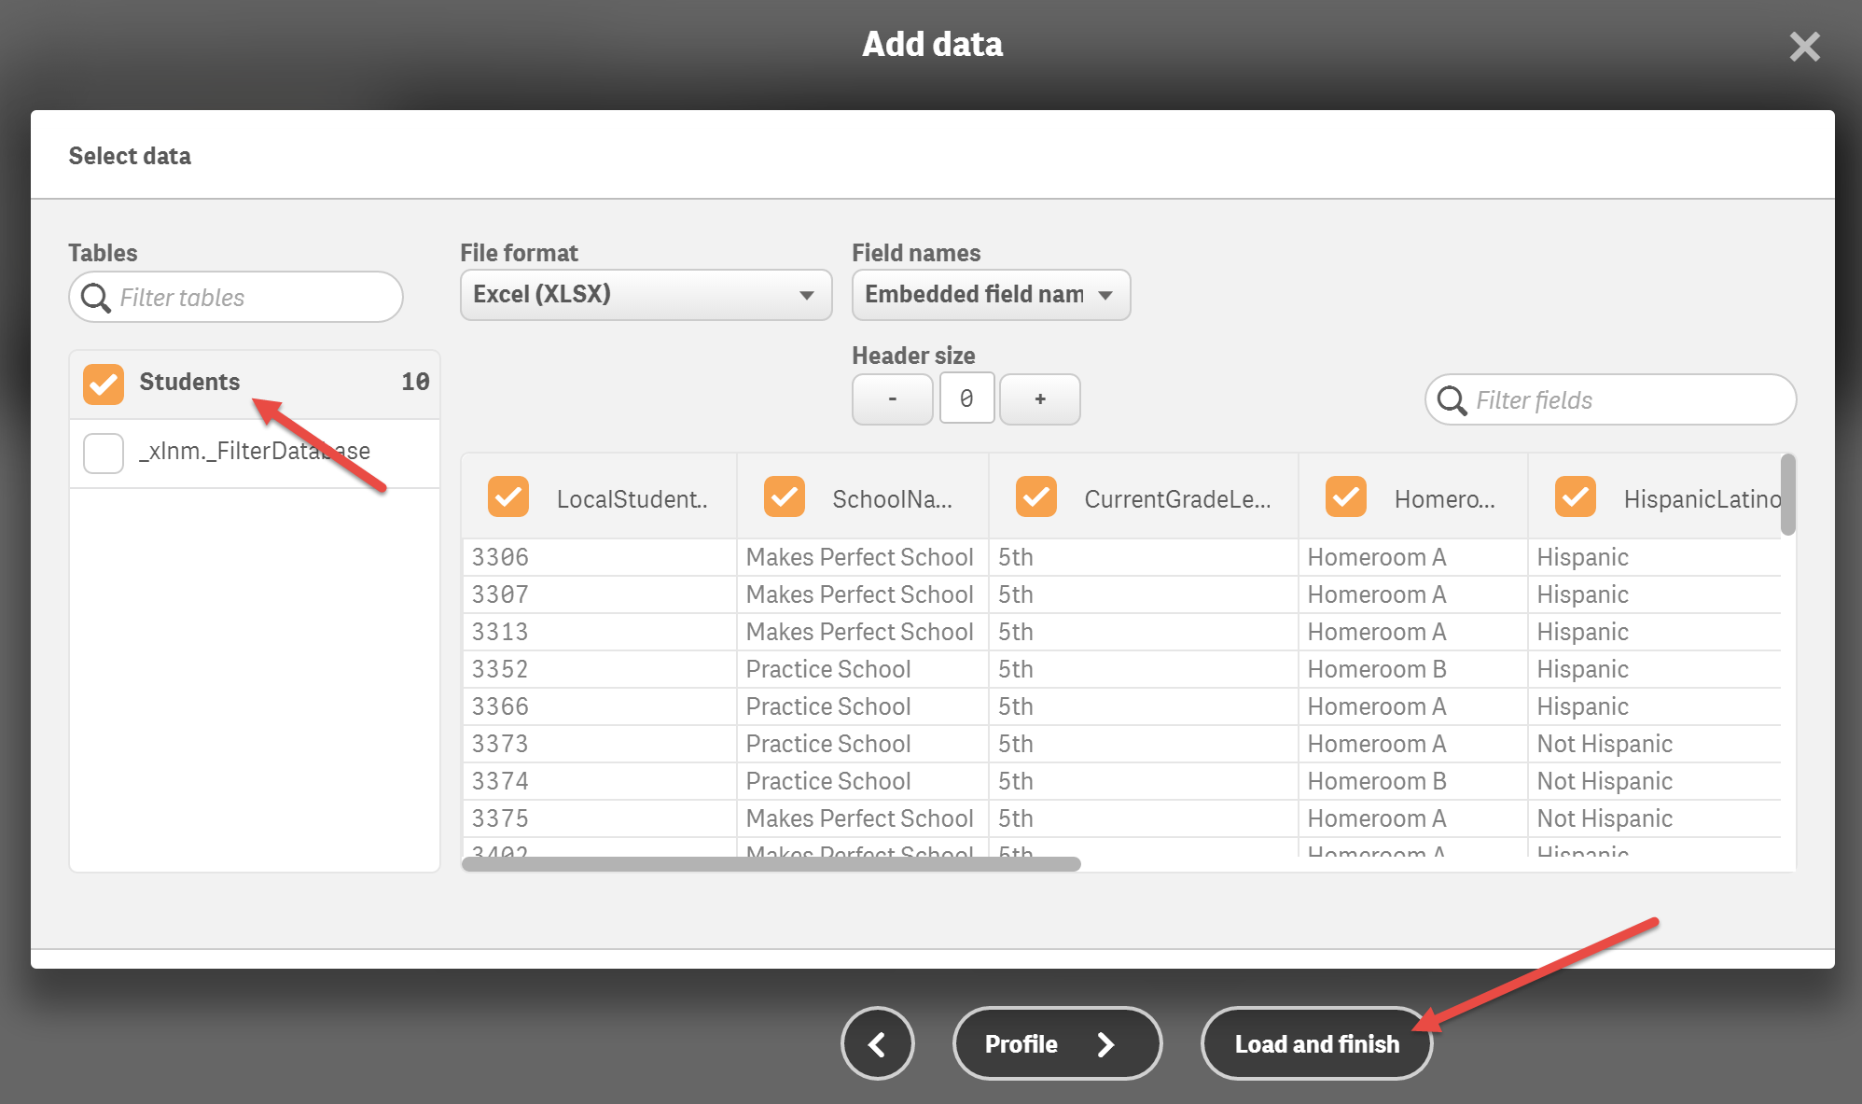
Then, add the “TrainingBehavior” and “TrainingAssessment” data files in the same manner
Your Qlik app data model should now look like this:
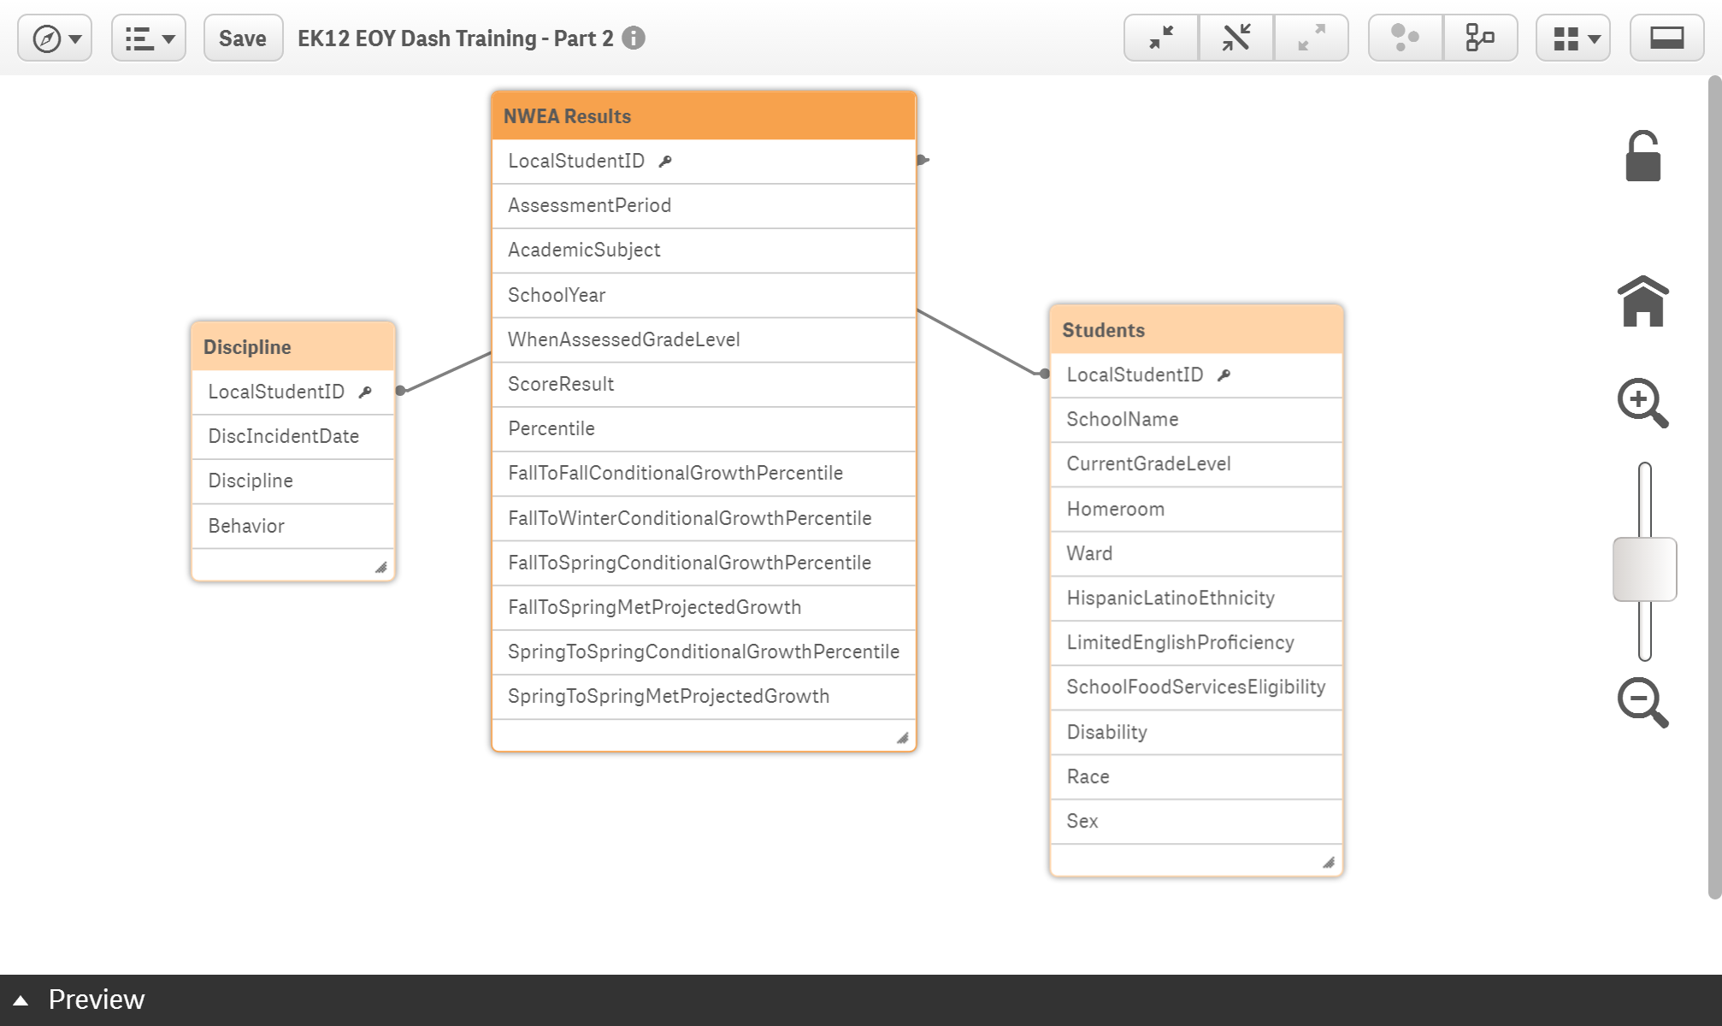

Step 2: Create Behavior Data Overview Sheet
Rename the app’s first sheet
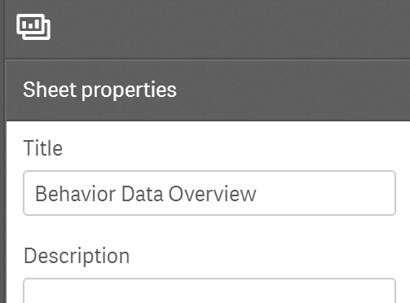

- Bar chart showing number of suspension incidents with new drill-down dimension for School>Grade>Homeroom
Drag-and-drop a bar chart from the charts menu at left. Resize it so that it only takes up ¼ of sheet
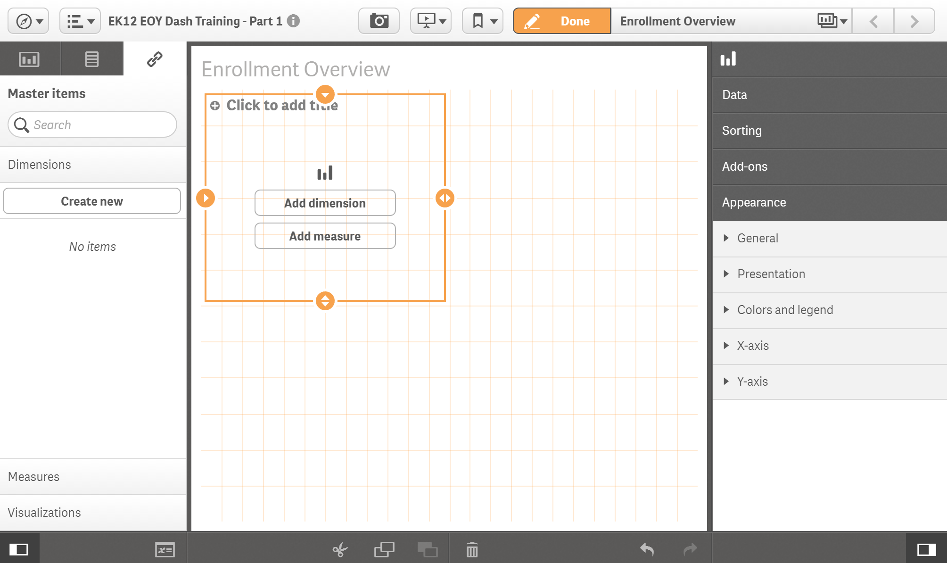
From the “Master Items” menu tab at left, click on dimensions and “create new”
Add school, current grade level, and homeroom (in that order) to the fields list for the drill down dimension
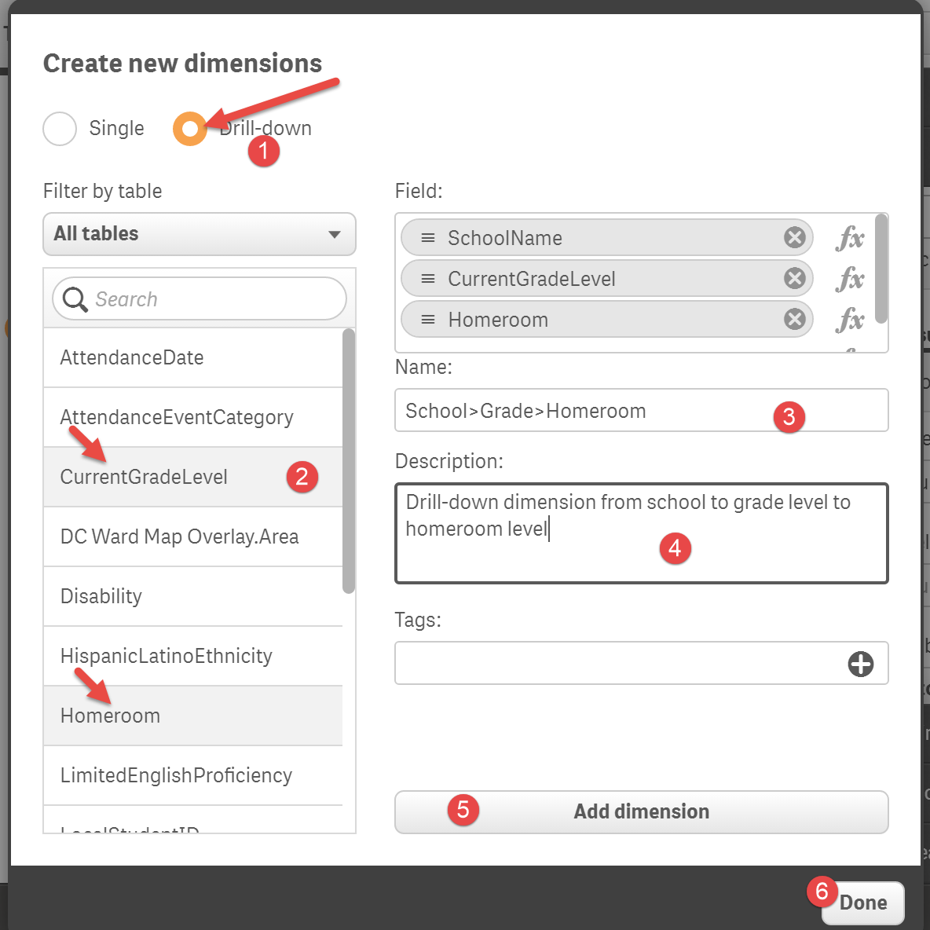
Drag and drop our new master dimension item “School>Grade>Homeroom” onto the empty chart
From the Fields menu in the Assets, drag and add “Behavior” from list of fields and add “count(Behavior)” to the chart to show the total number of behavioral incidents
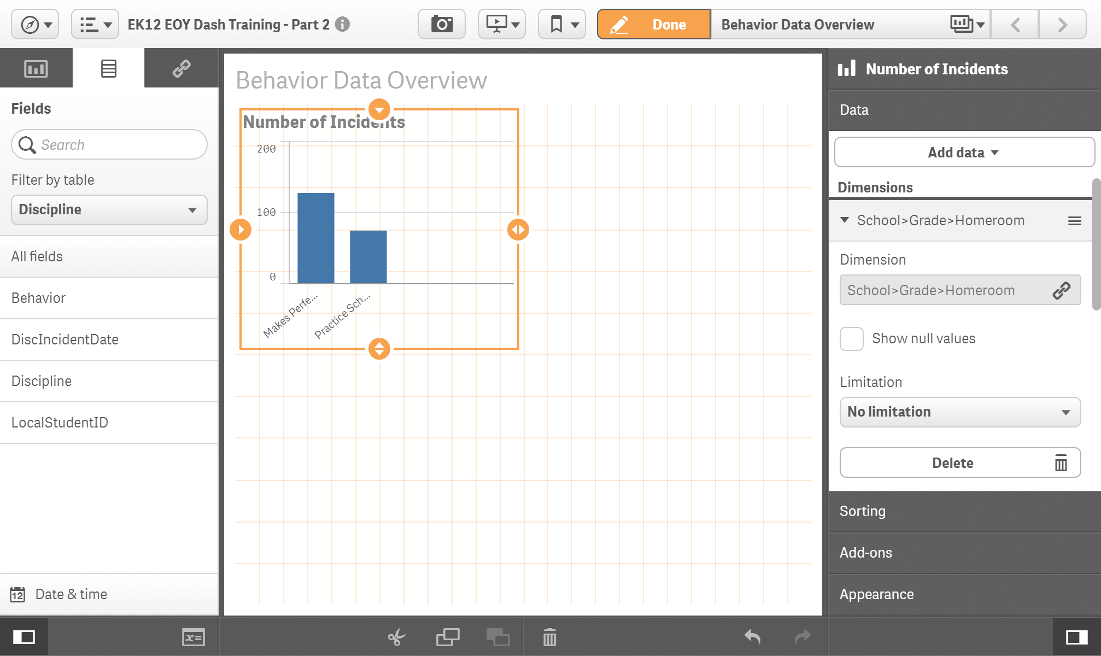

Use the Properties section to change bar colors, add data labels, and make changes to the x-axis and y-axis as well change the default sorting properties
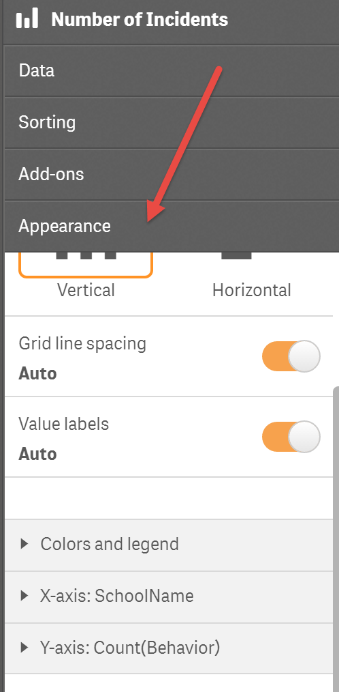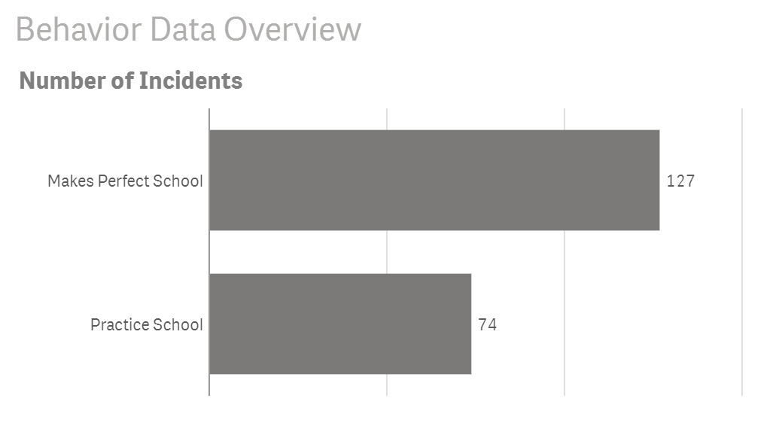

- Table with most disciplined students pre-sorted descending
Start by selecting “Dynamic Table” from charts list in our Assets, and dragging it into position. Then, from the list of Fields add “LocalStudentID,” “Homeroom,” and again “Behavior” as a count(Behavior)
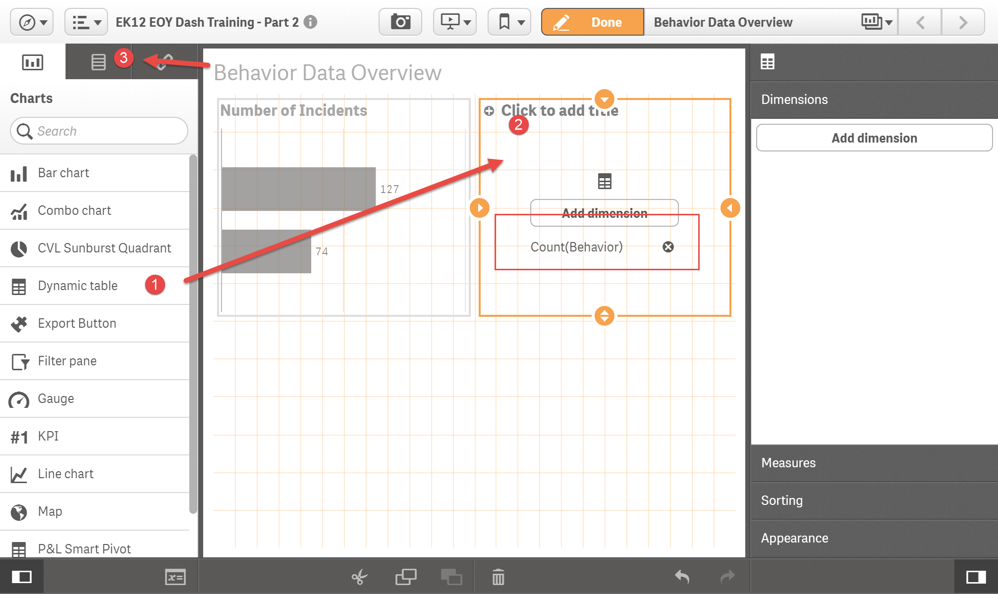
Then custom pre-sort the data so that number of behavior incidents is first and sorted descending
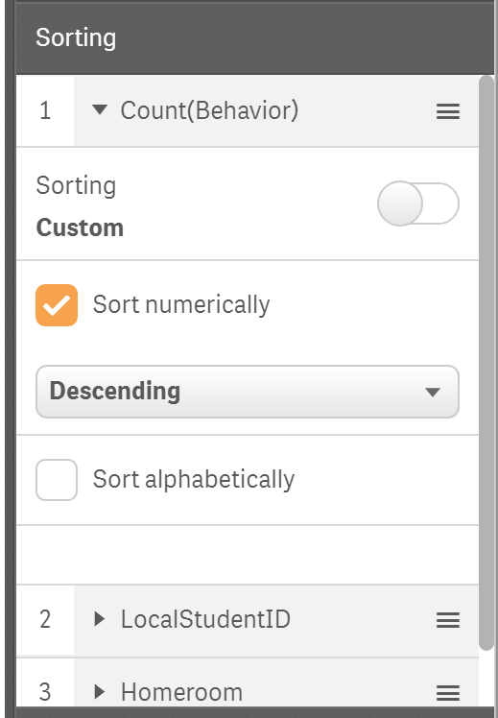

- Chart showing percent of incidents leading to suspensions by incident type using a custom master measure with set analysis
Start by adding another bar chart on the lower right of our Behavior Overview sheet
And then add the Field dimension “Behavior”

In the master items tab at left, click measures and create a new measure
Set Analysis: is a way to filter data within a particular calculation, basically performing the sum duties as the SUMIFS/COUNTIFS/AVERAGEIFS formulas in Excel – to use set analysis within a calculated measure you must include your conditions between two “curly carrots” or “Trojan hats” as I call them {< and >}
Our first intermediate calculated measure will be for “Percent Actions - Suspension” and it will look like this:
count({<Discipline={'In-school Suspension','Long-term OSS','Short-term OSS'}>}Discipline)
/
count(Discipline)
Notice our set analysis begins just inside the first parenthesis of the calculation and is bounded by Trojan hats (curly brace+less than on left and greater than+close curly brace on right.) In the metric, the first “set” counts all discipline actions that were an in-school or out-of-school suspension.
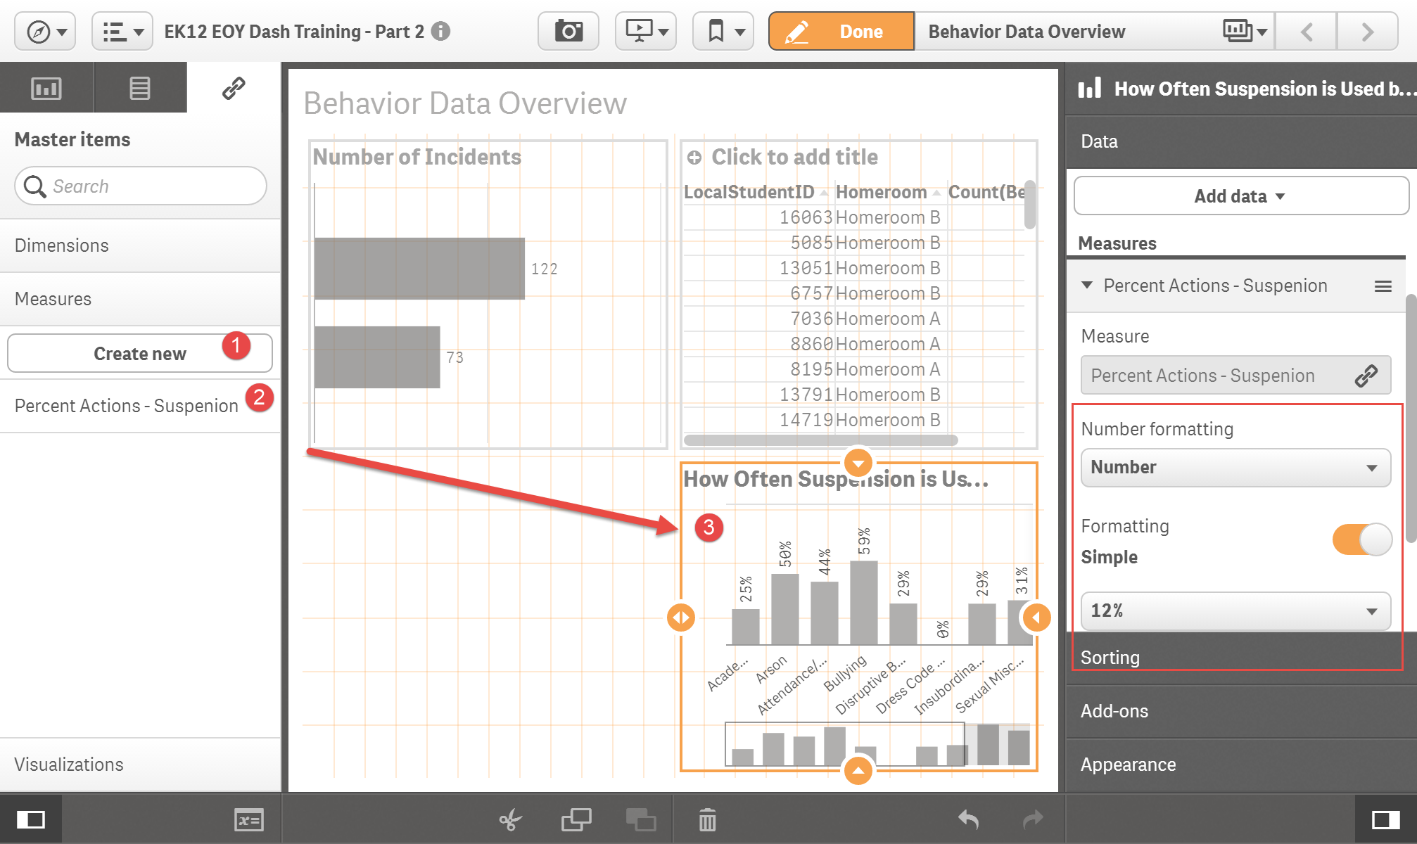

Check for understanding: How would the metric change if we wanted a percentage of incidents where Detention was the action taken? How would it change if we wanted to know the percent of incidents that were bullying?

- Line chart showing discipline incidents by month and school year
We must start by clicking on Dimensions from the master items tab and creating a new single dimension for “Incident Month” with formula:
month(DiscIncidentDate)
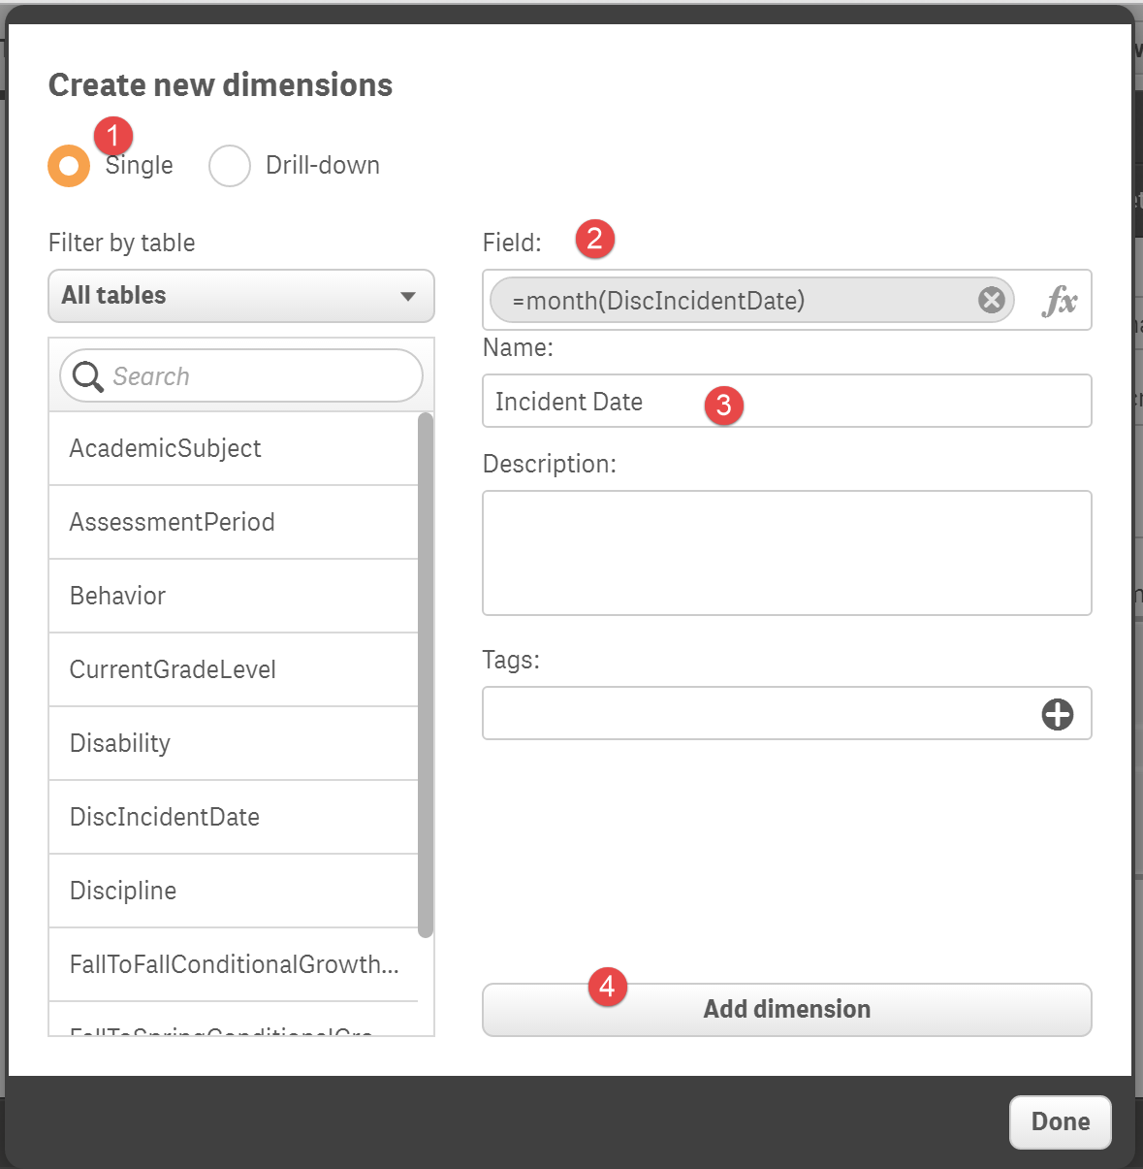
Now drag-and-drop a line chart, “Incident Month” from dimension list, SchoolYear from fields list, and Behavior as a count measure from the assets menus to the new line chart
Our months are likely sorted out of school year order, so we will need to add another Custom Sort expression to get them in the Aug-to-Jun order. In the properties menu at left under sorting, ensure Incident Month is listed first, unclick “Auto,” select sort by expression, and use this expression:
min(date(DiscIncidentDate))
This work-around formula is basically reordering months by the minimum date value for the full date instead of the month number…this way, the month Aug for a discipline incident occurring on 8/24/2014 gets sorted before the one occurring in January on 1/11/2015.
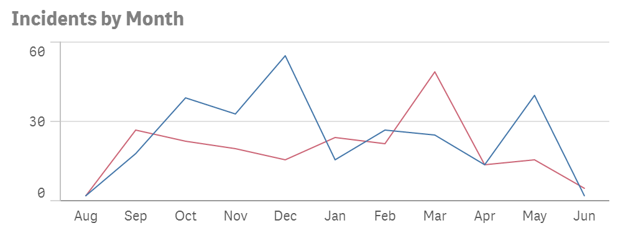
- KPI showing the Suspension Rate (from Equity Reports) using a function within set analysis within a function
For now we will move on to the assessment dashboard and come back to the advanced Suspension Rate metric…
Step 3: Create Assessment Overview Sheet
From the sheets menu at the top right, select “Create New Sheet” and name it “Assessment Overview”
- KPIs for Spring Participation Rate and Met Spring Growth Target with conditional color formatting
We will begin this sheet by adding two KPIs in the upper left hand corner of the sheet
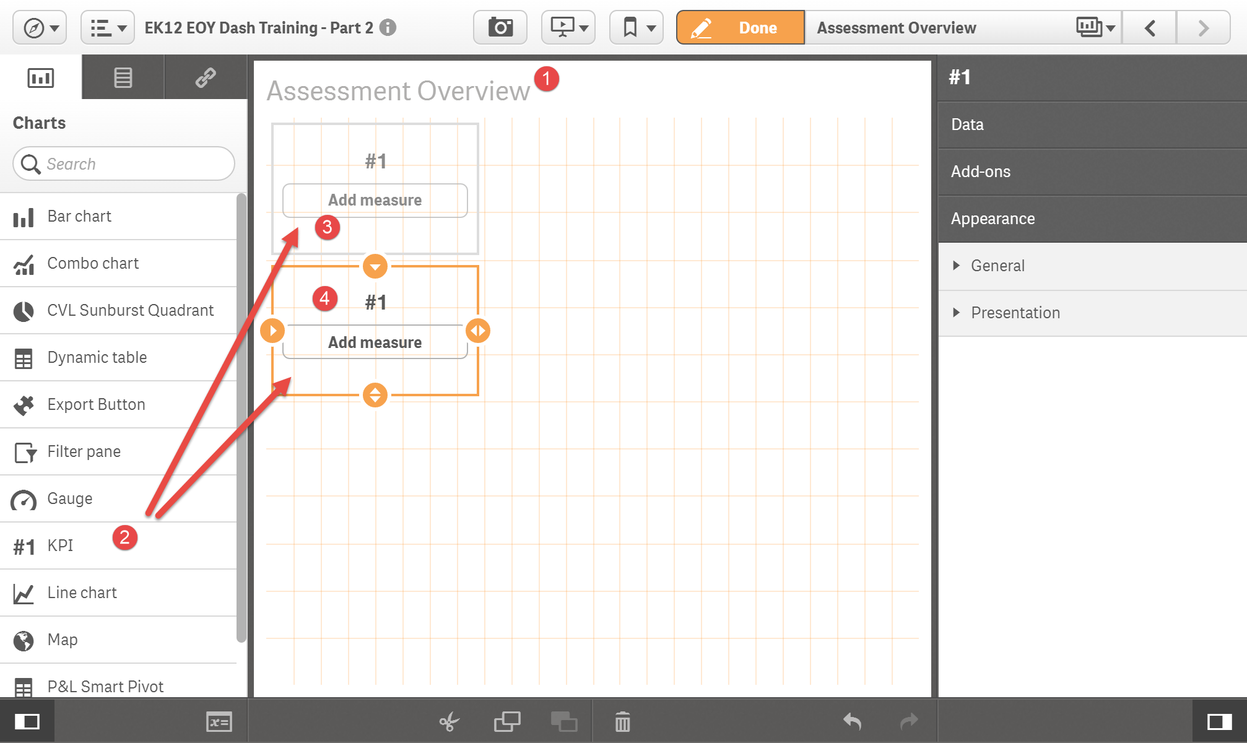
In our assessment dataset sample, each row represents one assessment record per student per subject per administration period.
Formula for percent of tested students meeting spring growth target:
count({<SpringToSpringMetProjectedGrowth={'Yes*','Yes'}>}ScoreResult)
/count({<SpringToSpringMetProjectedGrowth={'Yes*','Yes','No','No*'}>}ScoreResult)

Check for understanding: What should the formula for full participation rate look like?

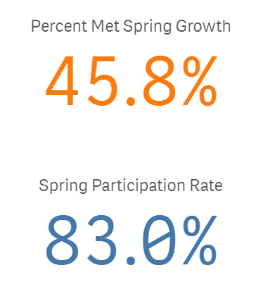
After creating the measure and adding it to the KPI, we can add some conditional color formatting to the KPI from the menu at right
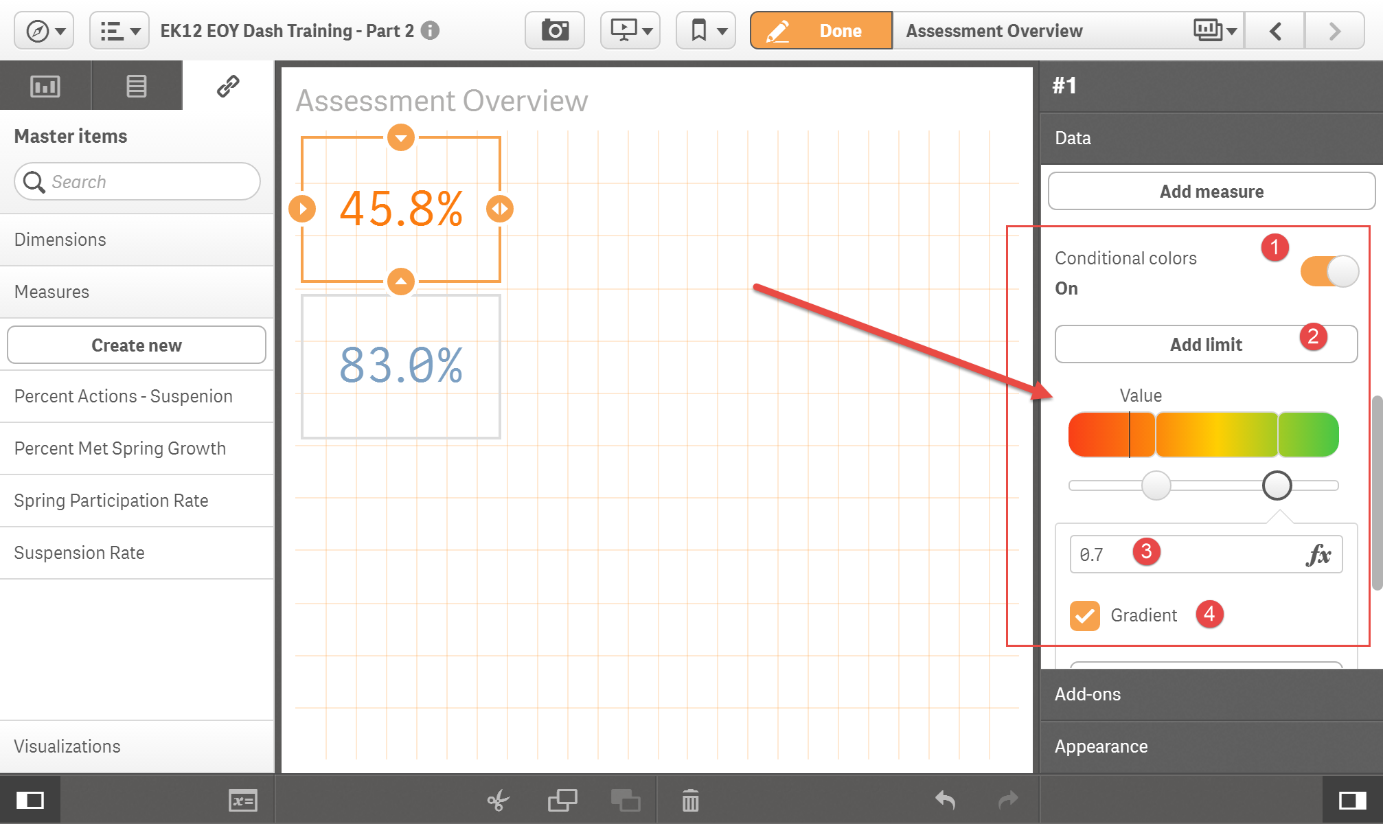

- Bar chart showing participation rate by School and Grade Level
Check for understanding: Can you recreate the bar chart below?
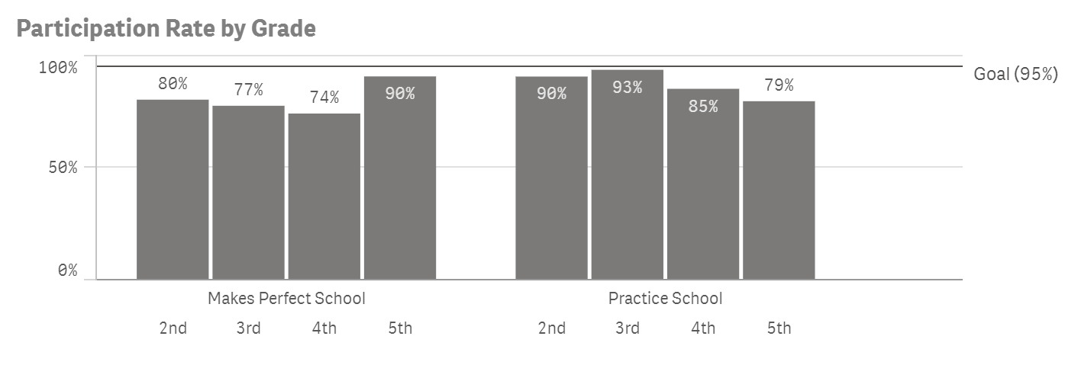

- Pivot table showing MGP by subject and season with custom color expression
Drag-and-drop a pivot table onto our assessment sheet lower left
Add the following fields: School, CurrentGradeLevel, Academic Subject
Create 3 new master measures that find the median growth percentile called “Fall MGP,” “Winter MGP,” and “Spring MGP” and then add them to the pivot table.
You can do it! Consider this yet another Check for Understanding
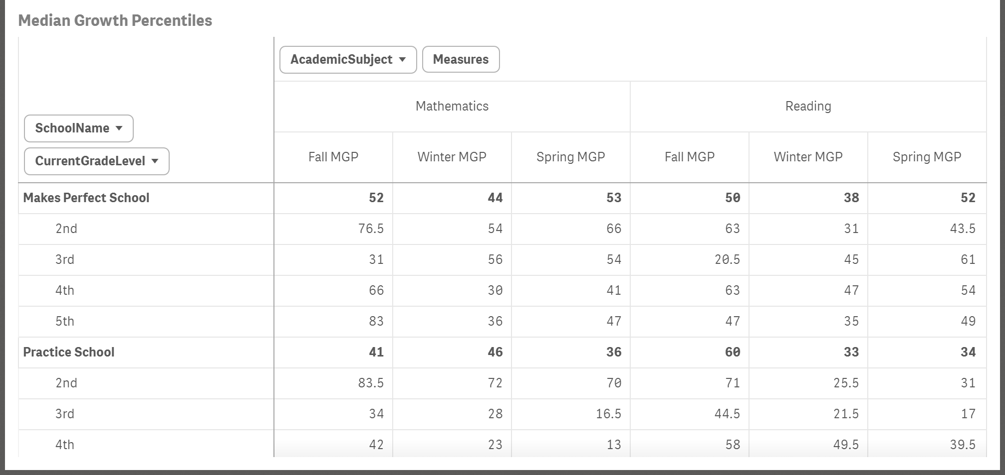
Now, how about with a little conditional formatting added at limits of 40 and 60 for MGP?
Try this function for Fall MGP custom background color:
colormapjet((100-median(FallToFallConditionalGrowthPercentile)+10)/100)
Repeat, by appropriately modifying, for Winter and Spring
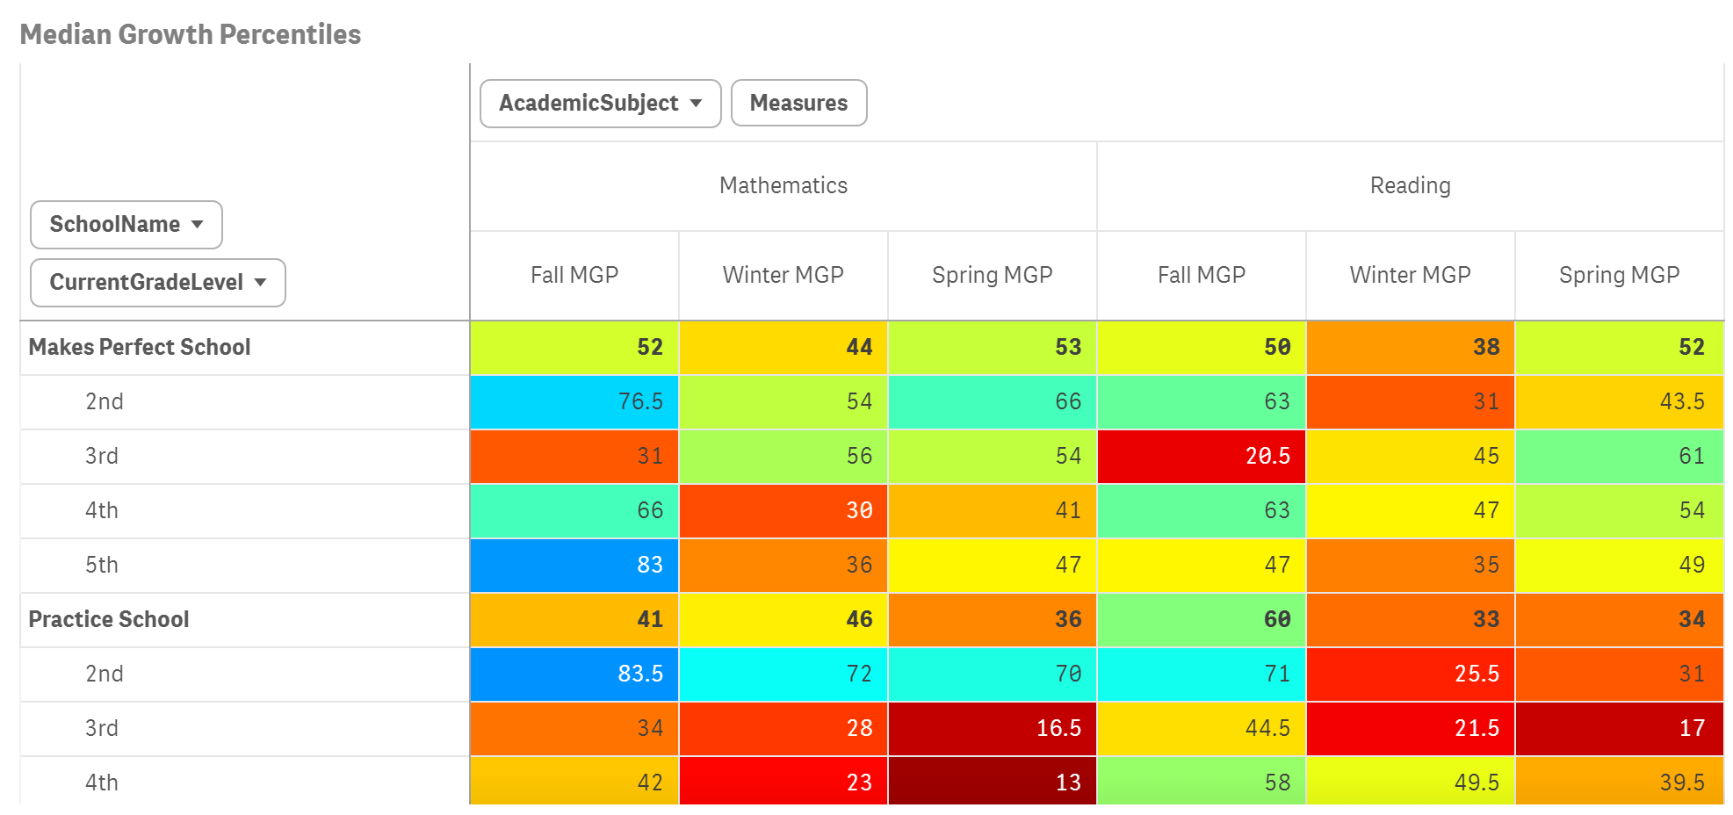

- Table showing students with highest average fall-to-spring growth by number of scale score points
You will need to use set analysis along with the “avg” function and “ScoreResult” field to make the right measure required.
Consider this your last Check for Understanding today
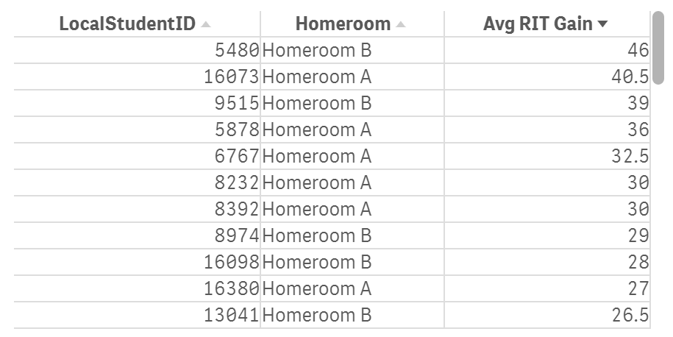

Step 4: Bonus Materials
- KPI showing the Suspension Rate (from Equity Reports) using a set analysis function within set analysis within a function
Here is the formula, Josh will break down what’s happening:
count({<LocalStudentID={"=count({<Discipline={'Long-term OSS','Short-term OSS'}>}Discipline)>0"}>}LocalStudentID)
/
count(LocalStudentID)

- Full control over colors by using valuelist function and colors by expression
Say we want more control over the line color representing this year and last with last year being in grey instead. We can do that but it takes a couple of extra steps and uses the valuelist function
Create a new single master dimension using this formula:
valuelist(‘SY1415’,’SY1516’)
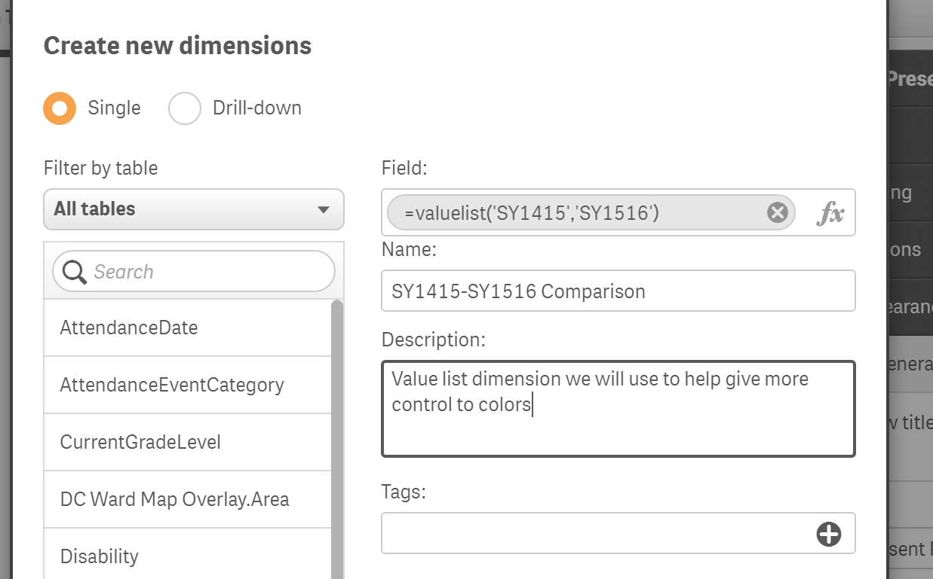
In the background, Qlik is basically creating a temp table with two rows where you can apply all sorts of attributes to items in the temp table list
We will use our new value list to create a new single measure to apply a formulas attribute to each element in the list:
If(valuelist('SY1415', 'SY1516')= 'SY1415',
count({<SchoolYear={'SY2014-15'}>}Behavior),
count({<SchoolYear={'SY2015-16'}>}Behavior))
After replacing the new measure created in the line chart, scroll down to Appearance>Colors and legend at right. Instead of colors being “Auto” switch it to Custom>By expression and we will add a custom color function
if(valuelist('SY1415','SY1516')='SY1415', rgb(192,192,192), rgb(0,179,255))

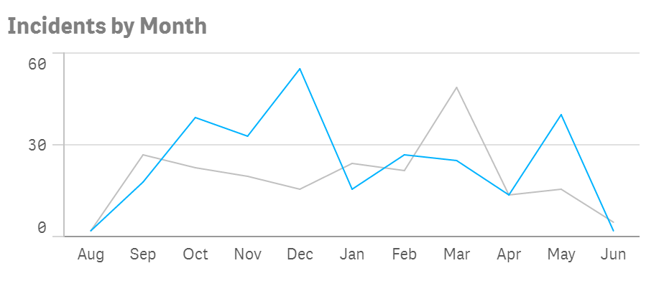

To find the RGB codes for other colors I use a site called Color Picker: http://www.colorpicker.com/

