Coaching for GROWth

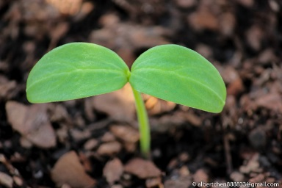

Do Now
What process do you use to help someone accomplish goals?

Coaching Model Rocket
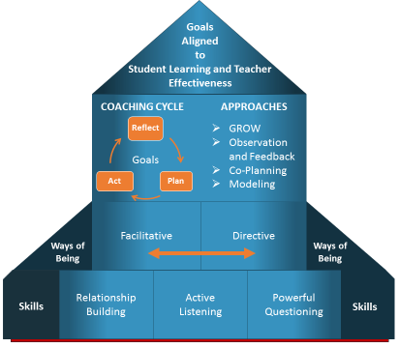
OBJECTIVES
Participants will be able to
- Coach their colleagues to set goals, assess current realities, identify options, and plan for a way forward
AGENDA
- Introduction and Framing
- Coaching Cycle
- The GROW Model
  - Goal
  - Reality
  - Options
  - Way Forward
- Putting it all together
- closing
Norms
- Norm #1: Monitor equity of voice–speak up or scale back as needed.
- Norm #2: Assume the best. Seek first to understand, then to be understood.
- Norm #3: Be vulnerable and authentic. Honor one another’s candor by maintaining confidentiality.
- Norm #4: Own your learning. Be the first to contribute. Challenge respectfully.
- Norm #5: Keep your eye on the prize. Maintain focus with high engagement and low technology.
- +1: Begin and end on time. Remember to have fun!

Introduction to GROW
- Goal setting for short/long term
- Reality checking to explore current situation
- Options and alternative strategies or courses of action
- What is to be done, When, by Whom, and the Will to do it (Way Forward)
Notes:

Goal
Establishing the goal—Define and agree on the goal or outcome to be achieved.

Establishing the Goal Video
Look For:
Evidence of using the skills of relationship building, active listening, and powerful questioning to establish the goal(s)
Relationship Building:  - Supporting goal attainment for improving student success and teacher effectiveness  - Establishing norms for how you will work together  - Creating and maintaining a coaching note taking document |  | Active Listening:  - Focused attention on words and expressions, recognizing meaning in body language, tone and gestures  - Using paraphrasing and summarizing to demonstrate and clarify understanding  - Making connections to previous coaching visits | Powerful Questioning:  - Open-ended to help accomplish goal(s)  - Solution oriented that help arrive at own solution(s)  - New awareness  - New action towards accomplishing goal(s)
Evidence: |  | Evidence: | Evidence:
Debrief Notes:
What went well?

What could make it even better?

GOAL Planning and Practice
Planning Notes:
What will you say/do to help your partner identify a clear high-leverage goal for the coaching visit that is aligned to short- and long-term goals for student learning and teacher effectiveness?

**You will practice this plan in a role play after we learn about R-reality. You will practice both Goal and Reality together.

Reality
Examine Current Reality—Ask partner to describe their Current Reality.

Exploring Current Reality Video
Look For:
Evidence of using the skills of relationship building, active listening, and powerful questioning to explore current reality
Relationship Building:  - Supporting goal attainment for improving student success and teacher effectiveness  - Establishing norms for how you will work together  - Creating and maintaining a coaching note taking document |  | Active Listening:  - Focused attention on words and expressions, recognizing meaning in body language, tone and gestures  - Using paraphrasing and summarizing to demonstrate and clarify understanding  - Making connections to previous coaching visits |  | Powerful Questioning:  - Open-ended to help accomplish goal(s)  - Solution oriented that help arrive at own solution(s)  - New awareness  - New action towards accomplishing goal(s)
Evidence: |  | Evidence: |  | Evidence:
Debrief Notes:
What went well?

What could make it even better?

REALITY Planning
Planning Notes:
What will you say/do to prompt your partner to analyze data that examines the current reality and performance against goals, including: strengths, challenges, relationships, or underlying dynamics?

Goal and Reality Practice
Practice Notes: B coaches A |  |  | Practice Notes: A coaches B
Takeaways:

Options
Explore the Options—Help your partner generate as many options as possible.

Brainstorming Options Video
Look For:
Evidence of using the skills of relationship building, active listening, and powerful questioning to brainstorm options
Relationship Building:  - Supporting goal attainment for improving student success and teacher effectiveness  - Establishing norms for how you will work together  - Creating and maintaining a coaching note taking document |  | Active Listening:  - Focused attention on words and expressions, recognizing meaning in body language, tone and gestures  - Using paraphrasing and summarizing to demonstrate and clarify understanding  - Making connections to previous coaching visits | Powerful Questioning:  - Open-ended to help accomplish goal(s)  - Solution oriented that help arrive at own solution(s)  - New awareness  - New action towards accomplishing goal(s)
Evidence: |  | Evidence: | Evidence:
Debrief Notes:
What went well?

What could make it even better?

OPTIONS Planning
Planning Notes:
What will you say/do to help your partner to brainstorm options before committing to a plan?

**You will practice this plan in a role play after we learn about R-reality. You will practice both Goal and Reality together.

Way Forward
Establishing the way forward—Get your partner to commit to specific action.

Establishing the Way Forward Video
Look For:
Evidence of using the skills of relationship building, active listening, and powerful questioning to establish the way forward
Relationship Building:  - Supporting goal attainment for improving student success and teacher effectiveness  - Establishing norms for how you will work together  - Creating and maintaining a coaching note taking document |  | Active Listening:  - Focused attention on words and expressions, recognizing meaning in body language, tone and gestures  - Using paraphrasing and summarizing to demonstrate and clarify understanding  - Making connections to previous coaching visits |  | Powerful Questioning:  - Open-ended to help accomplish goal(s)  - Solution oriented that help arrive at own solution(s)  - New awareness  - New action towards accomplishing goal(s)
Evidence: |  | Evidence: |  | Evidence:
Debrief Notes:
What went well?

What could make it even better?

WAY FORWARD Planning
Planning Notes:
What will you do/say to help your partner create a clear plan for action steps that are high leverage, bite-sized, and achievable with a clear plan for follow up?

Options and Way Forward Practice
Practice Notes: B coaches A |  |  | Practice Notes: A coaches B
Takeaways:

GROW Model: Additional Question Prompts
Goal: Goal setting for the session as well as for the short and long term
- What is the goal you have set for yourself?  - How will you know you have been successful? What does “wild success” look and sound like?  - What would you like to get out of this conversation?  - What would be the most helpful thing for you to take away from this conversation? | Notes:
Reality: Reality checking to explore the current situation
- Talk me through what’s happening now…  - What actions have you taken so far?  - What were the effects of that action?  - What has led up to the situation?  - What barriers or obstacles have you faced?  - What do you feel when…?  - What emotions are you left with when….?  - Can you give me a rating from one to ten for your level of confidence in your ability to…? | Notes:
Options: Options and alternative strategies or courses of action
- What are your options moving forward?  - What is the best/worst thing about that option?  - What if you had a larger budget? Larger staff?  - What if you knew the answer? What would it be?  - What if that obstacle did not exist? What would you do then?  - How would you rank each of the options from 1-10?  - What might one of your teachers suggest? One of your students? Your coach?  - What other approaches might bring you success with this?  - I have another couple of options. Would you like to have them? | Notes:
Way Forward: What is to be done, When, by Whom, and the Will to follow through
- What are you going to do?  - When are you going to do it?  - Will this action meet your goal?  - What obstacles might you meet along the way?  - Who needs to know?  - What support do you need?  - How and when are you going to get that support?  - Rate on a scale of 1 to 10 the degree of certainty you have you will carry out the agreed actions. | Notes:
Adapted from Coaching for Performance by John Whitmore
OPTIONAL: Putting it all Together: GROW
GROW Planning and Practice
Planning Notes:
Review previous notes and incorporate EBIs
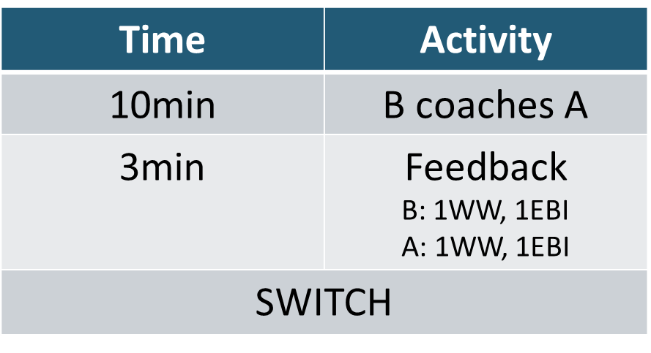

Practice Notes: B coaches A | Practice Notes: A coaches B
GROW Takeaways:

Journal
Date:
Facilitator:
Session Objectives:
Coach their colleagues to set goals, assess current realities, identify options, and plan for a way forward
Key Ideas
Takeaways
Goal
Reality
Options
Way Forward
Putting into action
How will you incorporate GROW into your work?

